Press Kit 2025 - Tasha Zappala
Press Photos:
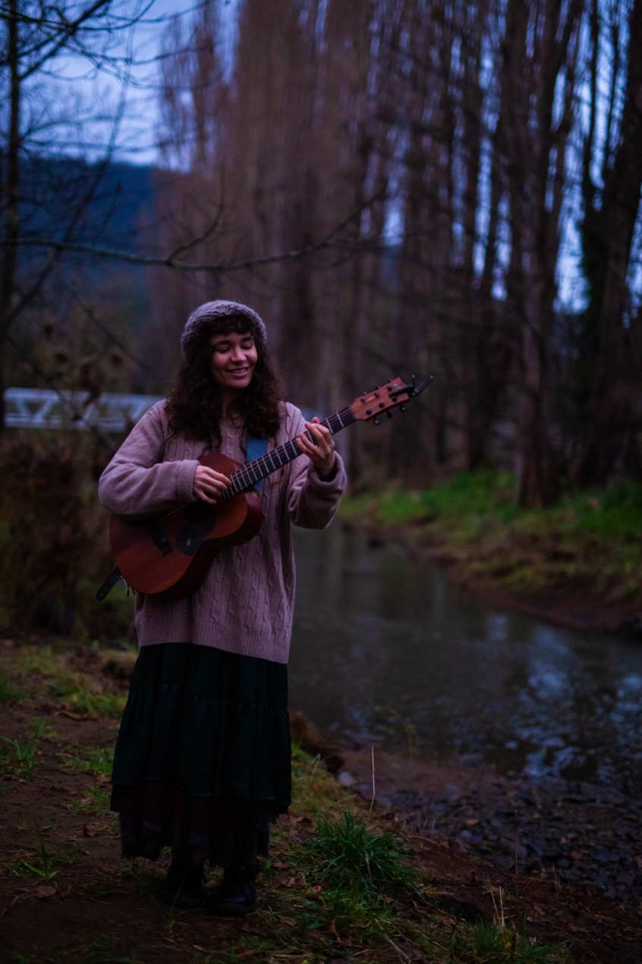
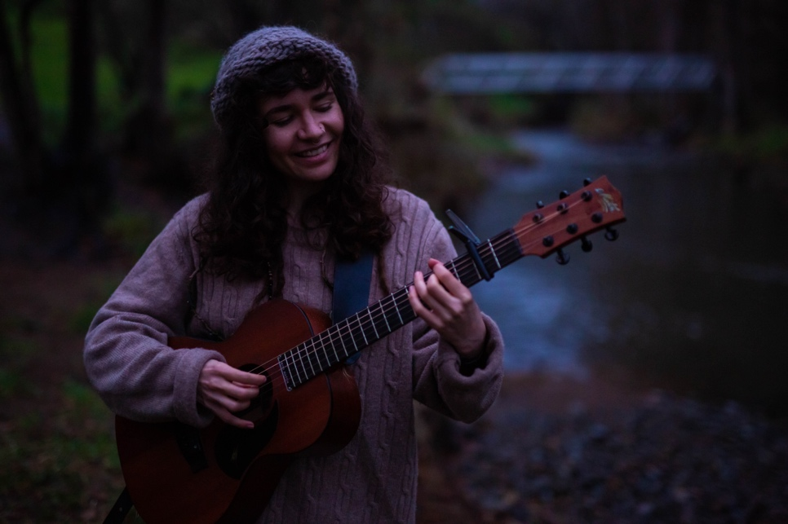

Links to Website and Social Media:
Website: www.tashazappala.com
Facebook: www.facebook.com/tashazappaladotcom
Instagram: www.instagram.com/tashazappala
Bandcamp: www.tashazappala.bandcamp.com
Youtube: https://www.youtube.com/c/TashaZappalaMusic
Soundcloud: https://soundcloud.com/tashazappala

Bio:
Singer-Songwriter and researcher Tasha Zappala crafts poetic and nature-inspired music. Originally from North Queensland and now based in Lutruwita, her performances are an exploration of sound and site, influenced by her work with field recordings and environmental sounds

Commercially released solo albums and soundscape releases:
Stoveside (2025), Late Spring (2025), Midwinter (2024), Early Summer (2024), Temperate (2024), Waratah Sessions (2023), From the Porch (2023), All at Once (2021), Rest Stop Rooibos (2020), among others.

Academic Qualifications:
Bachelor of Music (With Honours) 2017-2021
Tasmanian College of the Arts, Conservatorium of Music
PhD Candidate 2021-current
Tasmanian College of the Arts, Conservatorium of Music

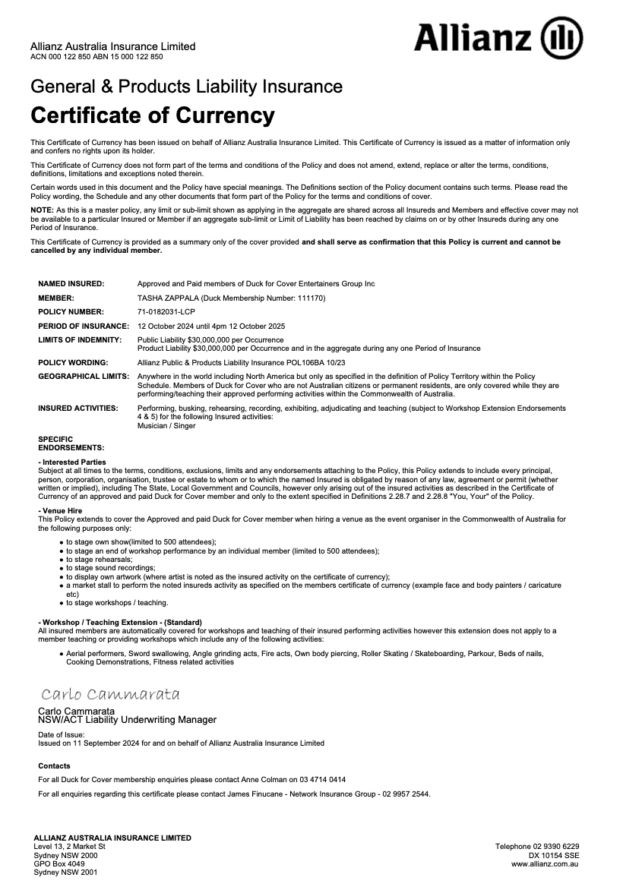
Sound Requirements

1 x XLR input for GTR and VOX (KMS105 microphone supplied by artist).
1 x D.I. for Stompbox
1 x XLR Input for Wasaphone microphone – This microphone is prone to feedback, please do not send any of this signal to the foldback.

