Press Kit - Tasha Zappala
Press Photos:
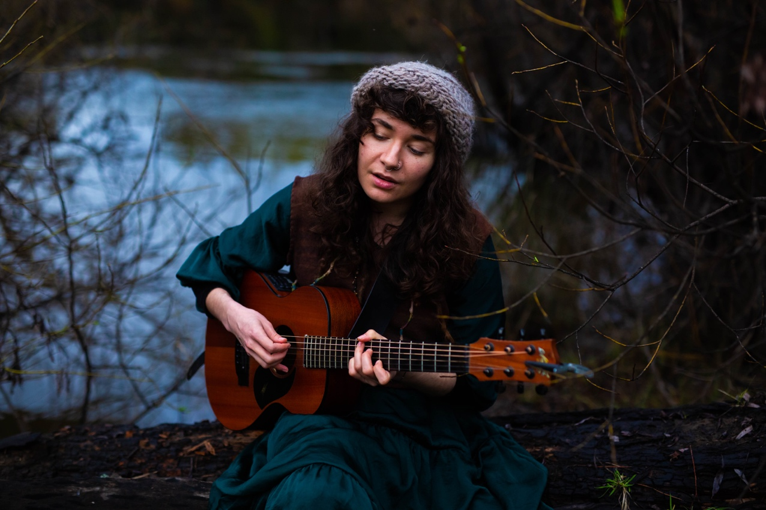
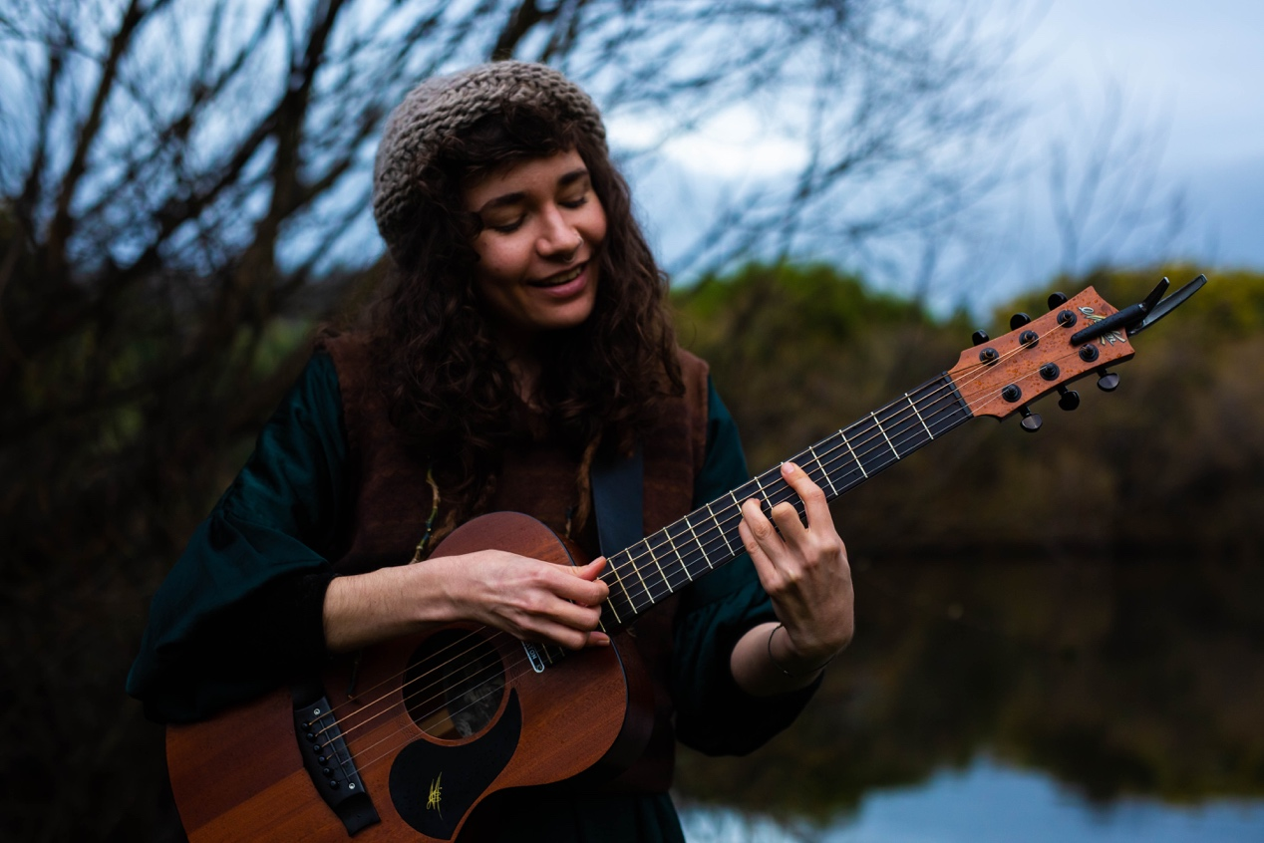
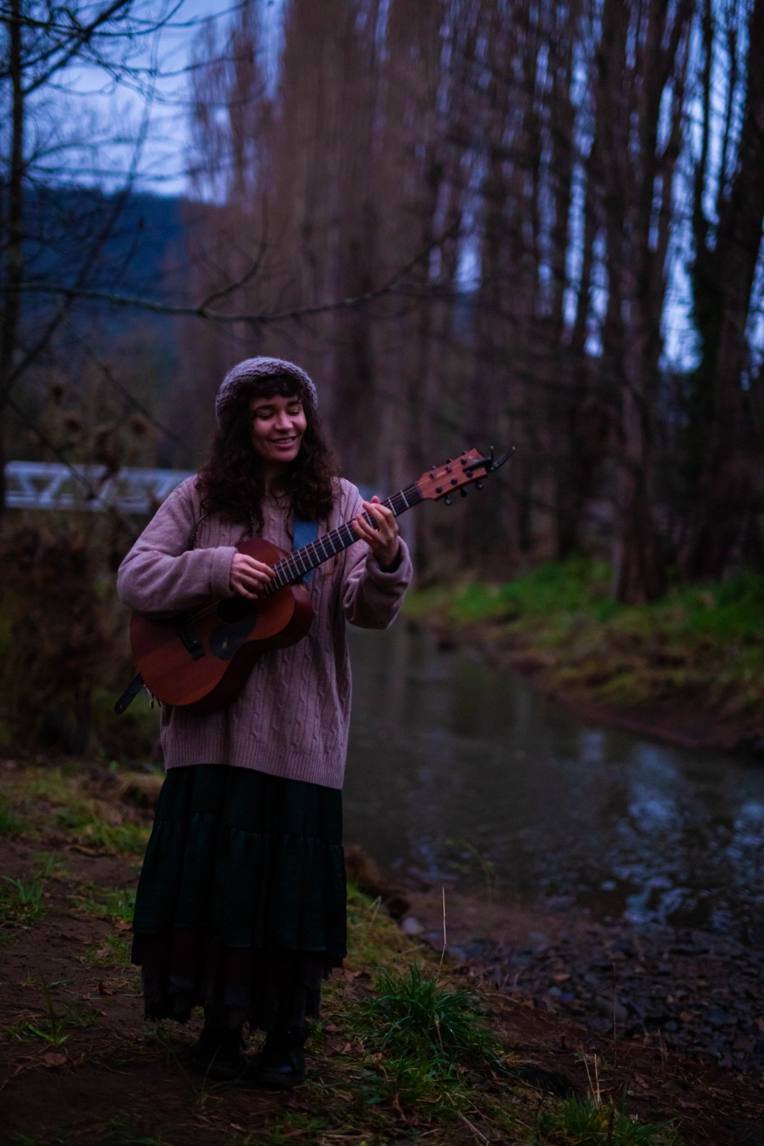
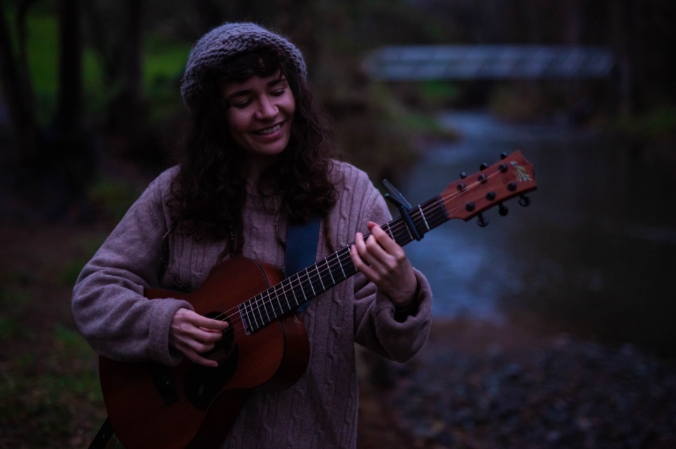
Links to Website and Social Media:
Website: www.tashazappala.com
Facebook: www.facebook.com/tashazappaladotcom
Instagram: www.instagram.com/tashazappala
Bandcamp: www.tashazappala.bandcamp.com
Spotify: https://spoti.fi/2FtvnNM
Youtube: https://www.youtube.com/c/TashaZappalaMusic
Twitter: https://www.twitter.com/tashazappala
Bandcamp: https://tashazappala.bandcamp.com/
Soundcloud: https://soundcloud.com/tashazappala

Bio:
Tasha Zappala is a singer-songwriter based in lutruwita/Tasmania. When not serenading, she spends her time in the southern woods making billypots of beans, drinking tea and capturing field recordings.

Having started her musical journey in thul garrie waja/gurrumbilbarra/North Queensland, Tasha has travelled the world performing her alt-folk songs across South America, Europe and the States; touring extensively across Australia and since 2020 has made lutruwita/Tasmania her home. Her music is influenced by her interactions with people she's met along her journey that have become friends as well as immersing herself in her environment and creating songs from the space between the natural world and the stage. When Tasha performs it is both ethereal and grounding and you can see the deep connection between an Artist and her songs that have the power to transport the listener to a place where time stands still.

Commercially released solo albums and EP’s:
Waratah Sessions (2023), From the Porch (2023), All at Once (2021), Rest Stop Rooibos (2020), Seasick (2019), Night Visions (2019), Dreamstate (2018), B-Sides (2017), Winter Year (2017), It’s Always Morning (2016), Drawing Trees (2014), among others.

Academic Qualifications:
Bachelor of Music (With Honours) 2017-2021
Tasmanian College of the Arts, Conservatorium of Music
PhD Candidate 2021-current
Tasmanian College of the Arts, Conservatorium of Music

Sound Requirements

1 x XLR input for GTR and VOX (microphone supplied – Neumann KMS 105) – Both microphone and the guitar will be in the same channel through a RC30 Loop pedal, sent to an amplifier provided by the artist (the artist can alter the levels between the microphone and guitar on stage). Reverb and effects will already be added to this channel.
1 x D.I. for Stompbox
1 x XLR Input for MKII custom vocal microphone – This microphone is prone to feedback, please do not send any of this signal to the foldback.

